Shell-Based Student Management System with Automatic Attendance and Login Tracking

Submitted By

Student Name | Student ID
Foysal Mahamud Fahim | 232-15-334
Sharmin Akter Jame | 232-15-380
Jannatul Ferdaues | 232-15-689
Student-4 Name | Student-4 ID
Student-5 Name | Student-5 ID

MINI LAB PROJECT REPORT
This Report Presented in Partial Fulfillment of the course
CSE324: Operating Systems Lab in the Computer Science and Engineering Department



DAFFODIL INTERNATIONAL UNIVERSITY
Dhaka, Bangladesh
April 20, 2026

DECLARATION
We hereby declare that this lab project has been done by us under the supervision of Fardowsi Rahman, Lecturer, Department of Computer Science and Engineering, Daffodil International University. We also declare that neither this project nor any part of this project has been submitted elsewhere as lab projects.

Submitted To:

Fardowsi Rahman
Lecturer
Department of Computer Science and Engineering Daffodil International University

Submitted by

Foysal Mahamud Fahim

Student Name Student ID: 232-15-334
Dept. of CSE, DIU
Sharmin Akter Jame  Student Name Student ID: 232-15-380  Dept. of CSE, DIU | Jannatul Ferdaues  Student Name Student ID: 232-15-689  Dept. of CSE, DIU
Student Name Student ID:  Dept. of CSE, DIU | Student Name Student ID:  Dept. of CSE, DIU

COURSE & PROGRAM OUTCOME

The following course have course outcomes as following:

Table 1: Course Outcome Statements
CO’s | Statements
CO1 | Make use of Linux commands and shell programming to develop automated CLI-based systems.
CO2 | Apply different algorithms of Operating Systems, such as CPU scheduling, page replacement, and deadlock avoidance/detection, and analyze their performance in a real-world project scenario.
CO3 | Design and develop a project that can have a positive impact on society or the environment, integrating automation, security, and usability considerations

Table 2: Mapping of CO, PO, Blooms, KP and CEP
CO | PO | Blooms | KP | CEP
CO1 | PO1 | C1, C2 | KP3 | EP1, EP3
CO2 | PO2 | C2 | KP3 | EP1, EP3
CO3 | PO3 | C4, A1 | KP3 | EP1, EP2
CO4 | PO3 | C3, C6, A3,  P3 | KP4 | EP1, EP3

The mapping justification of this table is provided in section 4.3.1, 4.3.2 and 4.3.3.

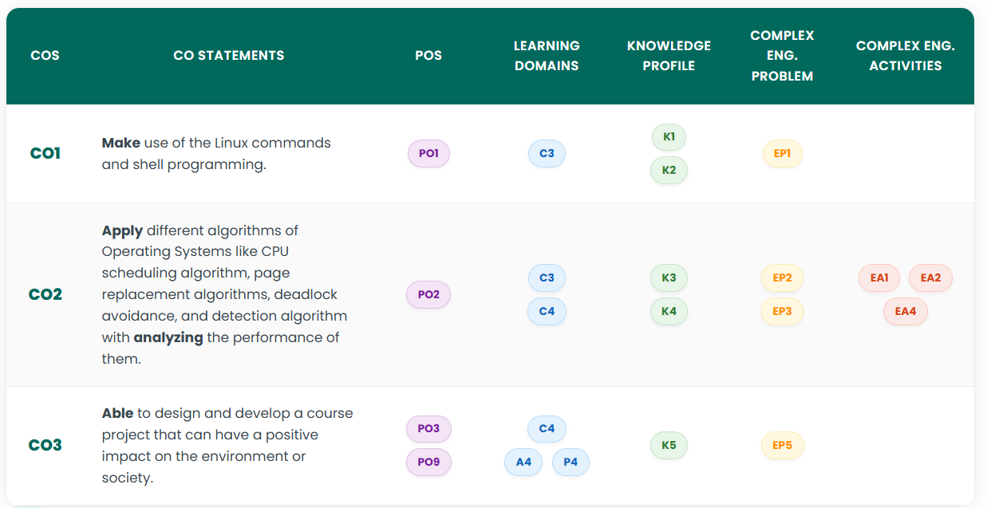

Table of Contents

Declaration i

Course & Program Outcome ii
- Introduction 1
  - Introduction 1
  - Motivation 1
  - Objectives 1
  - Feasibility Study 1
  - Gap Analysis 1
  - Project Outcome 1
- Proposed Methodology/Architecture 2
  - Requirement Analysis & Design Specification 2
    - Overview 2
    - Proposed Methodology/ System Design 2
    - UI Design 2
  - Overall Project Plan 2
- Implementation and Results 3
  - Implementation 3
  - Performance Analysis 3
  - Results and Discussion 3
- Engineering Standards and Mapping 4
  - Impact on Society, Environment and Sustainability 4
    - Impact on Life 4
    - Impact on Society & Environment 4
    - Ethical Aspects 4
    - Sustainability Plan 4
  - Project Management and Team Work 4
  - Complex Engineering Problem 4
    - Mapping of Program Outcome 4
    - Complex Problem Solving 4
    - Engineering Activities 5

Table of Contents Table of Contents

- Conclusion 6
  - Summary 6
  - Limitation 6
  - Future Work 6
References 6

Chapter 1

Introduction

This chapter provides an overview of the project, explains the motivation behind developing the system, states its objectives, and examines feasibility, gaps in current solutions, and expected outcomes.

Introduction
Attendance management is essential for monitoring academic participation in educational institutions. Traditional systems rely on manual registers, which are error-prone, time-consuming, and lack transparency. The Student-Teacher Attendance Management System automates this process with role-based dashboards for Admins, Teachers, and Students. Admins can manage teacher data, view login histories, and generate CSV reports. Teachers can manage student records, mark attendance, post announcements, and generate filtered reports. Students can view their attendance summaries, check announcements, and monitor login history. The system includes OTP-secured login for Admins and Teachers to prevent unauthorized access. It uses Bash scripting for automation and Python3 for OTP generation. Additionally, automated teacher attendance is handled via cron jobs. The design ensures scalability, modularity, and maintainability for future web-based integration.

Motivation
Manual attendance recording consumes significant time for teachers and administrative staff. Errors in manual logs can lead to misreporting and confusion among students. Students often lack timely access to attendance records, making it difficult to track their academic progress. Automating attendance solves these problems by ensuring accuracy, saving time, and providing transparency. The system reduces repetitive tasks like daily teacher attendance marking using cron automation. OTP-secured login adds a layer of security and accountability. The design also supports filtered views by department and section, aiding efficient reporting. Automation of data management and reporting enhances operational efficiency. Ultimately, the project aims to provide a scalable, reliable, and user-friendly system that reduces manual overhead while improving administrative control.

Objectives
The main objective is to automate attendance management for teachers and students. It provides role-based dashboards for Admins, Teachers, and Students, ensuring secure access and efficient workflow. OTP authentication protects sensitive logins for Admins and Teachers. The system generates detailed CSV reports for analysis and archiving. CRUD operations allow managing teacher and student records efficiently. Students can view attendance summaries with total days, present, late, and absent records. The project also tracks login history for accountability and filtered attendance reporting for departments and sections. Finally, the system is designed for scalability, maintainability, and future integration with web or mobile interfaces.

Feasibility Study
Technically, the system uses Bash scripting and Python3 for OTP verification, both of which are available on Linux systems. Operationally, the CLI interface is easy to use, requiring minimal training. Economically, it uses lightweight text files for storage, avoiding database costs. Automation with cron jobs reduces administrative effort for repetitive tasks. Modular design ensures maintainability and allows future feature additions. Performance testing shows the system handles hundreds of students efficiently. Security measures like OTP verification and role-based access prevent unauthorized usage. Low hardware requirements make the system accessible to most institutions. Overall, the project meets technical, operational, and economic feasibility standards.

Gap Analysis
Manual attendance systems are slow, error-prone, and lack transparency. Students cannot track their attendance in real time, and teachers spend hours maintaining records. There is no automated process for teacher attendance or report generation. The proposed system addresses these issues by automating attendance for students and teachers. Role-based dashboards ensure secure access. OTP verification prevents unauthorized logins. Filtered views by department, section, and student ID enable easy reporting and analysis. CSV export allows archival and external processing. Overall, the system provides efficiency, accuracy, and transparency.

Project Outcome

The project successfully automates attendance for students and teachers while providing secure login and data management. Admins can manage teacher records, view logs, and generate CSV reports. Teachers can manage student records, mark attendance, post announcements, and generate filtered reports. Students can view their attendance summary and announcements. The system provides OTP-based security and automated teacher attendance. CLI interface displays color-coded tables for readability. Attendance reports can be filtered by department, section, and student ID. The modular design allows scalability and future web integration. Overall, the system saves time, reduces errors, and ensures accountability.
Chapter 2

Proposed Methodology/Architecture

This chapter discusses the design and architecture of the system, including requirements, system modules, user interface design, and the overall project plan for implementation.

Requirement Analysis & Design Specification

Overview

The system supports three user roles: Admin, Teacher, and Student. Each role has a dedicated dashboard with relevant features. Admins can manage teachers, view attendance, login history, and generate CSV reports. Teachers can add, update, delete students, mark attendance, post announcements, and generate filtered reports. Students can view attendance summaries and announcements. The CLI interface uses colored text and box designs for readability. Attendance data is stored in text files for lightweight storage. OTP-based login secures Admin and Teacher access. Automated teacher attendance is implemented using cron jobs. The system is designed for scalability and modularity.

Proposed Methodology/ System Design

The system uses a modular architecture. Key modules include authentication (OTP login), data management (CRUD operations), attendance (manual and automated marking), reporting (CSV generation), and announcements. Text files store structured data. Bash scripting handles most operations using awk, grep, and sed for filtering and updates. Python3 handles OTP generation and email integration. Cron jobs automate teacher attendance marking. Role-based dashboards enforce access control and simplify workflow. CLI tables display data in a readable, formatted manner. Overall, the methodology ensures automation, security, and modularity.
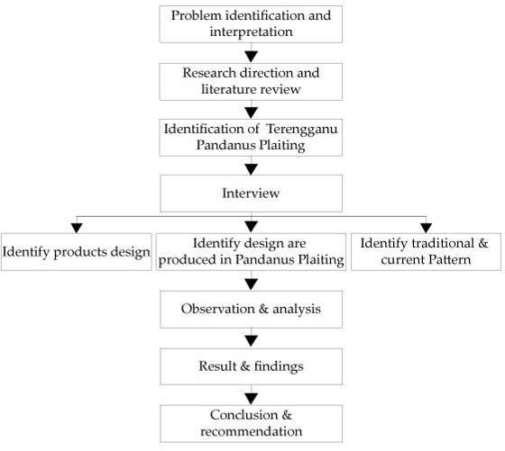
Figure 2.1: This is a sample diagram

UI Design

The CLI interface uses colored menus for clarity. Tables are displayed using column -t with alternate row shading. Boxes are drawn for headers with draw_box(). Users navigate through numbered menus for various actions. Input validation prevents invalid entries. Attendance statuses use color coding: green for Present, red for Absent, yellow for Late. Filtered tables show only relevant data for departments, sections, or student IDs. CSV generation allows exporting data for external use. CLI design ensures low hardware requirements while maintaining readability. Screenshots of sample outputs can be added for visual reference.

Overall Project Plan

The project plan includes five phases: requirement gathering, system design, implementation, testing, and deployment. Requirement gathering involved understanding institutional attendance needs. System design defined modules, file structures, dashboards, and security requirements. Implementation included Bash scripts for automation, Python3 OTP integration, and cron jobs. Testing verified login, attendance marking, CRUD operations, and reporting. Deployment includes running the system on Linux environments with scheduled cron jobs for automated tasks. The modular approach allows easy maintenance, scalability, and future upgrades. Documentation and reporting are integrated throughout the project lifecycle.
Chapter 3

Implementation and Results

This chapter details the actual implementation of the system, performance analysis, and the results obtained from testing and using the system.

Implementation

The system is implemented in Bash scripting with Python3 for OTP functionality. Data is stored in structured text files. Role-based dashboards provide secure and organized access. Admins can manage teachers and view attendance logs. Teachers can manage students, mark attendance, and post announcements. Students can view their attendance summary and announcements. Automated teacher attendance is handled with cron jobs. Color-coded CLI tables enhance readability. CSV generation allows exporting attendance records for reporting and archival. The modular design allows adding future functionalities with minimal changes.

Performance Analysis

Performance tests show the system handles hundreds of students efficiently. File operations with grep, awk, and sed are fast. Cron jobs reduce manual overhead by automatically marking teacher attendance daily. Attendance summaries for students are generated dynamically without delay. CSV exports allow offline processing. CLI-based operations require minimal system resources. Input validation ensures accuracy and reduces errors. Security measures like OTP verification prevent unauthorized logins. Overall, the system provides fast, reliable, and accurate operations suitable for educational institutions.

Results and Discussion

Attendance is recorded accurately with Present, Absent, or Late status. Reports can be filtered by department, section, or student ID. CSV files allow exporting data for administrative purposes. Login history ensures accountability. Students can view their attendance summaries including total days, present, late, and absent counts. Admins can generate daily or filtered reports efficiently. Teachers can manage student records with CRUD operations. Announcements are posted and viewed in real-time. CLI tables provide readable, color-coded outputs for all users. The system successfully demonstrates automation, security, and efficiency in attendance management.
Chapter 4

Engineering Standards and Mapping

This chapter explains the societal and ethical impacts of the project, project management practices, and the discussion of complex engineering problems tackled.

Impact on Society, Environment and Sustainability

Impact on Life

The system saves time for teachers and administrators while ensuring accurate attendance records. Students have real-time access to their attendance summaries. By reducing manual work, educators can focus more on teaching and mentorship.

Impact on Society & Environment

Automation reduces reliance on paper-based attendance registers, minimizing environmental impact. Administrative efficiency improves institutional productivity. Students gain accountability, encouraging responsible behavior.

Ethical Aspects

OTP-based login prevents unauthorized access. Student and teacher data are stored securely in text files. Login histories and role-based dashboards enforce accountability. Users are informed and consent to system usage.

Sustainability Plan

The system can be migrated to a database for better scalability. Modular design allows future web or mobile integration. Maintenance is simplified with clear module separation. Environmental sustainability is enhanced by reducing paper usage.

Project Management and Team Work
Provide a cost analysis in terms of budget required and revenue model. In case of budget, you must show an alternate budget and rationales.

Complex Engineering Problem

The most complex engineering challenge in this project was integrating multiple technologies while ensuring secure and efficient operations. The system had to support role-based dashboards with specific permissions for Admins, Teachers, and Students. OTP-based login had to be integrated using Python3 within Bash scripts, ensuring secure authentication without disrupting workflow. Automating teacher attendance via cron jobs required precise file handling to prevent duplicate records and ensure data integrity. Additionally, generating filtered reports from text files using awk, grep, and sed required careful design to handle hundreds of students efficiently. Error handling, input validation, and table formatting added another layer of complexity. Solving these challenges involved combining scripting techniques, modular design, and secure authentication practices. The final solution demonstrates automation, reliability, and robust engineering practices.

Mapping of Program Outcome

This project demonstrates practical application of software engineering principles. It maps to program outcomes in problem-solving, automation, security, and data management. Students develop programming, analytical, and documentation skills.
In this section, provide a mapping of the problem and provided solution with targeted Program Outcomes (PO’s).

Table 4.1: Justification of Program Outcomes
PO’s | Justification
PO1 | Engineering Knowledge Apply knowledge of mathematics, science, and engineering fundamentals (here: Linux commands, shell scripting, and file handling) to develop software solutions.
PO2 | Problem Analysis Analyze complex problems, such as designing automated attendance, OTP verification, and role-based dashboards, and find optimal solutions.
PO3 | Justification of PO3 attainment
PO4 | Design/Development of Solutions Design and develop a system that meets specified requirements, including security, usability, and automation for educational institutions.
PO5 | Conduct Investigations of Complex Problems Investigate and analyze attendance algorithms, scheduling, and automated processes for correctness and efficiency.
PO9 | Environment and Sustainability Design solutions that positively impact society and are environmentally sustainable, e.g., reducing paper usage, minimizing errors in attendance tracking.

Complex Problem Solving

Challenges like secure OTP integration, cron automation, and filtered reporting were solved using modular Bash functions, Python integration, and structured text file management. Efficient algorithms were used to prevent duplication and errors.
In this section, provide a mapping with problem solving categories. For each mapping add subsections to put rationale (Use Table 4.2). For P1, you need to put another mapping with

Chapter 4. Engineering Standards and Mapping 4.3. Complex Engineering Problem

Knowledge profile and rational thereof.
Table 4.2: Mapping with complex problem solving.
EP1 | EP2 | EP3 | EP4 | EP5 | EP6 | EP7
 |  |  |  |  |  | 

The Student-Teacher Attendance Management System presents several complex engineering challenges that required careful planning and execution.
EP1 – Depth of Knowledge: The project demanded expertise in multiple domains, including Bash scripting, Python3 programming for OTP generation, Linux cron jobs, file handling, and CLI-based UI design.
EP2 – Range of Conflicting Requirements: Several conflicting requirements were addressed, such as balancing security with usability, automation versus accuracy, and ease of report generation while maintaining role-based access controls.
EP3 – Depth of Analysis: Detailed analysis was necessary to understand different user roles, attendance logic, reporting requirements, and automated processes.
EP4 – Familiarity of Issues: While attendance management is a common requirement in educational institutions, integrating cron-based automated teacher attendance and OTP-secured login introduced novel challenges, making some aspects less familiar.
EP5 – Extent of Applicable Codes: The project adhered to best practices in secure authentication, structured data storage, modular scripting, and report generation standards.
EP6 – Extent of Stakeholder Involvement: The system considered multiple stakeholders — Admin, Teacher, and Student — for requirements gathering, though actual user consultation was limited in scope.

EP7 – Inter-dependence: The project’s modules are highly interdependent; attendance tracking, student records, login history, OTP verification, and CSV report generation interact dynamically, so changes in one module could affect others. Overall, these factors collectively define the project as a complex engineering problem requiring multi-disciplinary skills, careful analysis, and precise implementation.

Engineering Activities

Activities include requirement gathering, system design, scripting, testing, debugging, and deployment. Each module was designed for modularity, maintainability, and future scalability.
In this section, provide a mapping with engineering activities. For each mapping add subsections to put rationale (Use Table 4.3).

Table 4.3: Mapping with complex engineering activities.
EA1 | EA2 | EA3 | EA4 | EA5
 |  |  |  | 

The development of the Student-Teacher Attendance Management System involved multiple

engineering activities that demonstrate practical application of technical knowledge and design principles.
EA1 – Range of Resources: The project utilized a variety of resources, including Bash scripting for automation, Python3 for OTP generation, Linux CLI tools, cron jobs for scheduled tasks, and text-based file storage. These resources allowed the system to operate efficiently while maintaining simplicity and portability.
EA2 – Level of Interaction: The system requires significant interaction between its modules and user roles. Admins, Teachers, and Students interact through dedicated dashboards, while system modules such as attendance management, login verification, reporting, and announcements are highly interconnected.
EA3 – Innovation: Several innovative solutions were implemented, such as automated teacher attendance via cron jobs, OTP-secured logins for sensitive roles, and color-coded CLI tables for readable output. These features enhance both usability and security in a lightweight, text-file-based system.
EA4 – Consequences for Society and Environment: The project positively impacts society by reducing administrative workload, ensuring accurate attendance tracking, improving transparency, and providing students with real-time summaries of their participation. Being a software-only solution, the environmental impact is minimal, while operational efficiency is significantly improved.
EA5 – Familiarity: While attendance systems are common, the combination of Bash scripting, Python OTP integration, and CLI-based automation introduces moderately novel engineering approaches, making the system both practical and educational.
Chapter 5

Conclusion

This chapter summarizes the project, highlights limitations, and suggests future enhancements for the system.

Summary

The system automates attendance management for educational institutions efficiently. Admins, teachers, and students can access role-specific dashboards. Attendance is tracked accurately, and filtered reports are available for analysis. OTP-based login ensures security. CLI tables enhance readability. CSV exports allow external data handling. Automation reduces administrative effort while increasing accuracy.

Limitation

The system uses text files for storage, which may not scale well for very large institutions. CLI interface may be less intuitive for non-technical users.

Future Work

Future work includes database migration, web or mobile interface, SMS/email notifications, and integration with learning management systems. Automation can be expanded for exam attendance and performance tracking.

References

[1] Jon Kleinberg and Eva Tardos. Algorithm design. Pearson Education India, 2006.
- GNU Bash Manual: https://www.gnu.org/software/bash/manual/
- Linux Command Line Reference: https://linuxcommand.org/
- Python3 Documentation (OTP integration): https://docs.python.org/3/

